**EPIDEMOLOGY OF TYPHOID FEVER AMONG STUDENTS OF FEDERAL POLYTECHNIC, MUBI, ADAMAWA STATE, NIGERIA**

**BY**

**ISMAIL IBRAHIM**

**ST/PT/ND/23/102**

**EDWARD REMEMBRANCE**

**ST/PT/ND/23/106**

**PHILIP PRINCE**

**ST/PT/ND/23/116**

**DEPARTMENT OF PHARMACEUTICAL TECHNOLOGY,**

**SCHOOL OF SCIENCE AND TECHNOLOGY,**

**FEDERAL POLYTECHNIC, MUBI, ADAMAWA STATE.**

**AUGUST, 2025**

# TITLE PAGE

**EPIDEMOLOGY OF TYPHOID FEVER AMONG STUDENTS OF FEDERAL POLYTECHNIC, MUBI, ADAMAWA STATE, NIGERIA**

**BY**

**ISMAIL IBRAHIM**

**ST/PT/ND/23/102**

**EDWARD REMEMBRANCE**

**ST/PT/ND/23/106**

**PHILIP PRINCE**

**ST/PT/ND/23/116**

**BEING A PROJECT SUBMITTED TO THE DEPARTMENT OF BIOMEDICAL AND PHARMACEUTICAL TECHNOLOGY, SCHOOL OF APPLIED SCIENCE, IN PARTIAL FULFILLMENT OF THE REQUIREMENT FOR THE AWARD OF NATIONAL DIPLOMA (ND) IN PHARMACEUTICAL TECHNOLOGY, THE FEDERAL POLYTECHNIC, MUBI, ADAMAWA STATE**

**AUGUST, 2025**

# DECLARATION

We hereby declare that this work which titled “**Epidemiology of Typhoid Fever Among Students of Federal Polytechnic, Mubi, Adamawa State, Nigeria**”. As a result of research effort and findings and to the best of our knowledge and belief that this work has never been submitted to any institution for the award of any certificate and various sources used has been duly acknowledged by the use of referencing.

…………..…………..... ……..………….....

ISMAIL IBRAHIM Date

ST/PT/ND/23/102

…………..…………..... ……..………….....

EDWARD REMEMBRANCE Date

ST/PT/ND/23/106

…………..…………..... ……..………….....

PHILIP PRINCE Date

ST/PT/ND/23/116

# CERTIFICATION

This project entitled “**Epidemiology of Typhoid Fever Among Students of Federal Polytechnic, Mubi, Adamawa State, Nigeria**” meets the regulation governing the award of National Diploma in Pharmaceutical Technology of the Federal Polytechnic, Mubi and is approved for its contribution to knowledge and literary presentation.

…………..…………..... ……..………….....

**Mr. Caleb Nina Sule**  Date

(Project Supervisor)

…………..…………..... ……..………….....

**Dr. Mahmoud Mohammed Tanko** Date

(Head of Department)

…………..…………..... ……..………….....

(External Examiner) Date

# DEDICATION

We dedicated this research work to God almighty for his infinite love and mercy upon us and also for giving us sound knowledge, wisdom and better understanding to successfully write this piece of project and to him be all the glory and honor.

# ACKNOWLEDGEMENTS

We want to acknowledge Almighty God for his infinite mercy and protection throughout our academic activities. And for the understanding in achieving our academic success.

We also recognize our Supervisor Mr. Caleb Nina who took time, despite his busy schedule to direct and guide us throughout this research work.

We also acknowledge the Head of Department Pharmaceutical Technology Dr. Mahmoud Mohammed Tanko for his moral encouragement throughout our period of study.

We also acknowledge all Staff of Pharmaceutical Technology Department for their support and encouragement and the knowledge they’ve impacted on us throughout our studies.

We also want to appreciate our parents for their love and care and for giving us the opportunity to be trained and achieve our dreams.

Finally, we appreciate the efforts of our uncles and aunties, for their encouragement and support throughout the course of our study and also our friends and relatives, course mates and all well-wishers. We love you all, may the Almighty God bless you abundantly, Amen.

# TABLE OF CONTENTS

TITLE PAGE i

DECLARATION ii

CERTIFICATION iii

DEDICATION iv

ACKNOWLEDGEMENTS v

TABLE OF CONTENTS vi

LIST OF TABLES viii

CHAPTER ONE 1

INTRODUCTION 1

1.1. Background of the Study 1

1.2. Statement of the Problem 2

1.3. Aim and Objectives 2

1.3.1 Aim: 2

1.3.2. Objectives: 3

1.4. Significance of the Study 3

1.5. Scope of the Study 3

CHAPTER TWO 5

LITERATURE REVEIW 5

2.1. Review of Related Work 5

2.2. Theoretical Review 9

2.2.1. The Germ Theory of Disease 9

2.2.2. The Social Ecological Model (SEM) 10

2.2.3. The Health Belief Model (HBM) 11

2.2.4. The Epidemiologic Triad Model 11

2.2.5. Theory of Planned behaviour (TPB) 12

2.2.6. Application to the Study 12

CHAPTER THREE 13

MATERIALS AND METHOD 13

3.1. List of Materials Required 13

3.1.2. Laboratory Testing Materials 13

3.2. Methodology 14

3.2.1. Research Design 14

3.2.2. Study Area 15

3.2.3. Study Population 15

3.2.4. Sample Size Determination 16

3.2.5. Sampling Technique 17

3.2. 6. Inclusion and Exclusion Criteria 17

3.2.7. Data Collection Methods 18

3.2.9. Data Analysis 18

CHAPTER FOUR 20

RESULTS AND DISCUSSION 20

4.1. Results 20

4.1.1. Test Results 20

4.1.2. Analysis and Discussion 24

CHAPTER FIVE 26

SUMMARY, CONCLUSION AND RECOMMENDATIONS 26

5.1. Summary 26

5.2. Conclusion 27

5.3. Recommendations 27

REFERENCES 29

# CHAPTER ONE

# INTRODUCTION

## 1.1. Background of the Study

Typhoid fever is a systemic infectious disease caused by *Salmonella enterica* serovar Typhi and is primarily transmitted through the ingestion of contaminated food or water. It continues to be a serious public health challenge, especially in low- and middle-income countries where water sanitation infrastructure is inadequate (Akinyemi et al., 2021). Nigeria remains one of the countries with a high burden of typhoid fever, with frequent outbreaks reported across different states (Afolabi et al., 2023).

In educational institutions like Federal Polytechnic Mubi, the risk of typhoid fever among students is heightened due to factors such as overcrowded hostels, shared sanitary facilities, and limited access to safe drinking water. As young adults may not consistently practice good hygiene or understand disease prevention strategies, the transmission rate can be significantly high (Mohammed et al., 2022). Investigating the epidemiological trends of typhoid fever in this specific population is essential to inform evidence-based interventions and reduce the disease burden.

The global burden of typhoid fever is significant, with estimates indicating 11 to 20 million cases and over 150,000 deaths annually (WHO, 2021). In Nigeria, typhoid remains endemic and is often exacerbated by the interplay of poor sanitation, unclean water supplies, and low public health literacy (Otegbayo et al., 2022). Within the tertiary education environment, students live in close quarters and often rely on shared food vendors and water sources, increasing their susceptibility to infection.

A study conducted by Oladele et al. (2021) reported a 14.1% prevalence of typhoid fever among febrile patients in a Nigerian community, highlighting its widespread nature. Similarly, Musa et al. (2022) identified a significant prevalence among pregnant women in Kogi State, attributing this to the consumption of untreated water and low health education. Furthermore, Usman et al. (2023) conducted a study at Nasarawa State University, where 42% of student patients tested positive for typhoid using the Widal test and 34% by blood culture, emphasizing the vulnerability of students.

Additional research in Gombe State linked risk factors such as consumption of unboiled water, inadequate handwashing, and reliance on street food to increased typhoid infections (Adamu & Bello, 2023). These findings are particularly relevant to students at Federal Polytechnic Mubi, where similar environmental and behavioural patterns exist.

## 1.2. Statement of the Problem

Despite nationwide awareness campaigns and public health interventions, typhoid fever continues to pose a significant health threat to students at Federal Polytechnic Mubi. The disease contributes to academic setbacks due to absenteeism, increased financial stress from medical expenses, and potential complications if not promptly treated. Several risk factors, including unsafe water sources, unhygienic food handling practices, and poor sanitation facilities, persist within the campus environment (Chukwu et al., 2022). There is a lack of current data regarding the actual prevalence and contributing factors of typhoid fever in this student population, thus necessitating this study.

## 1.3. Aim and Objectives

## 1.3.1 Aim:

To investigate the epidemiology of typhoid fever among students of Federal Polytechnic Mubi, Adamawa State, Nigeria.

## 1.3.2. Objectives:

1. To determine the prevalence of typhoid fever among students of Federal Polytechnic Mubi.
2. To identify major risk factors associated with the occurrence of typhoid fever in the student population.
3. To assess students’ knowledge and awareness of typhoid fever transmission, prevention, and treatment.
4. To recommend appropriate preventive and control strategies based on the study findings.

## 1.4. Significance of the Study

This study will provide valuable insights into the current status of typhoid fever among students of Federal Polytechnic Mubi. By identifying the prevalence and risk factors, it will support the development of targeted health interventions and education programs. The findings will also serve as a reference for local health authorities and the Polytechnic’s management to implement practical solutions, such as improved sanitation infrastructure, clean water supply systems, and campus-wide awareness campaigns (Adebayo et al., 2023). Moreover, this study contributes to the existing body of knowledge on typhoid fever epidemiology in institutional settings, where risk factors are often overlooked in broader public health research.

## 1.5. Scope of the Study

The scope of this study is limited to students of Federal Polytechnic Mubi, Adamawa State. It will focus on identifying the prevalence, risk factors, and awareness levels concerning typhoid fever. The study will involve both quantitative and qualitative data collection through structured questionnaires, review of medical records from the school clinic, and possibly serological testing where feasible. While the findings may not be generalized beyond the Polytechnic, they will provide a context-specific understanding of the disease dynamics in this environment, serving as a model for similar institutions across Nigeria.

# CHAPTER TWO

# LITERATURE REVEIW

## 2.1. Review of Related Work

Typhoid fever, caused by *Salmonella enterica* serovar Typhi, remains a significant public health concern in many low- and middle-income countries. Its epidemiology is shaped by a complex interplay between microbial factors, human behaviours, environmental sanitation, and healthcare infrastructure. Typhoid fever is a systemic infection primarily caused by the bacterium *Salmonella enterica* serovar Typhi, and less commonly by *Salmonella Para typhi*. It is a significant cause of morbidity and mortality in developing countries, particularly where access to clean water and proper sanitation is limited (WHO, 2021). The bacterium is transmitted via the fecal-oral route, primarily through ingestion of contaminated food or water, and is endemic in many regions of sub-Saharan Africa, South Asia, and parts of Latin America (Crump et al., 2021).

The global burden of typhoid fever has been extensively reassessed in recent decades. Crump (2019) highlights the improved availability of high-quality incidence data, particularly in endemic regions such as South Asia and sub-Saharan Africa. However, substantial gaps remain due to diagnostic limitations and inconsistent surveillance systems (Radhakrishnan et al., 2018). These disparities often result in underestimation or mischaracterization of the true disease burden.

Localized studies offer valuable insights into the variability of typhoid fever across different settings. In the Mekong Delta region of Vietnam, Lin et al. (2000) documented high seasonal incidence rates, linked to waterborne transmission and limited sanitation infrastructure. Similarly, in Iraq, Medhat and Aljanabay (2022) identified significant spatial variation in typhoid prevalence, with urban areas bearing a heavier burden due to population density and poor infrastructure.

By contrast, high-income countries exhibit reduced endemicity but remain vulnerable to travel-associated cases. Yew et al. (1993), in a study of Singapore, reported low transmission levels domestically but noted that returning travellers frequently accounted for new infections.

Surveillance accuracy is hindered by heterogeneous diagnostic methods and case definitions. Marchello and Hong (2019), in a systematic review and meta-analysis, revealed wide variance in reported incidence rates, largely attributable to differences in blood culture sensitivity and healthcare access. This diagnostic inconsistency continues to challenge global estimations and policy planning.

The rise of multidrug-resistant typhoid strains adds urgency to the epidemiological challenge. Gupta (1994) focused on paediatric populations, emphasizing that resistance to first-line antibiotics not only complicates treatment but also contributes to sustained transmission in high-burden areas. These findings underscore the need for ongoing antimicrobial surveillance and the development of new therapeutic strategies.

Globally, typhoid fever is responsible for an estimated 11–20 million illnesses and between 128,000–161,000 deaths annually (WHO, 2021). The disease disproportionately affects children and young adults in low-income settings. According to Mogasale et al. (2022), sub-Saharan Africa accounts for a large portion of global typhoid cases, with Nigeria being one of the most affected countries. The burden of typhoid in Nigeria is aggravated by poor sanitation, low access to clean drinking water, and overcrowding, especially in urban and peri-urban settings.

In their national review, Akinyemi et al. (2021) highlighted that many urban centers in Nigeria still experience frequent outbreaks of typhoid fever due to poor waste disposal systems, ineffective water treatment, and food safety lapses. Oladele et al. (2021) noted a 14.1% prevalence among febrile patients in southwestern Nigeria, reinforcing the disease's endemic nature in the country.

Tertiary institutions often serve as hotspots for communicable diseases due to high population density, communal living conditions, and shared facilities such as hostels, cafeterias, and toilets (Musa et al., 2022). Within these environments, students may have limited control over their water sources or food hygiene, and frequently depend on street vendors, whose hygiene practices are often unregulated.

Studies from various Nigerian universities have reported a high prevalence of typhoid among students. For instance, Usman et al. (2023) observed that 42% of students tested positive for typhoid using the Widal test and 34% via blood culture at Nasarawa State University. Similarly, Adamu and Bello (2023) linked typhoid infections among students in Gombe metropolis to the use of untreated water, consumption of roadside food, and infrequent handwashing practices.

These findings are consistent with those reported by Mohammed et al. (2022), who identified lack of awareness and poor hygiene as major contributing factors to typhoid transmission among students in northern Nigeria.

Several risk factors have been identified in the transmission of typhoid fever. These include the use of unclean water for drinking or cooking, poor hand hygiene, open defecation, and consumption of food from roadside vendors (Chukwu et al., 2022). According to Adebayo et al. (2023), students in tertiary institutions are often unaware of the importance of personal hygiene and water safety, making them particularly vulnerable.

Furthermore, poor environmental sanitation around student hostels contributes to the persistence of *S. Typhi* in the immediate surroundings. Afolabi et al. (2023) emphasized the role of shared and often unhygienic sanitary facilities as a major transmission channel within campuses. In a related study, Musa et al. (2022) reported that over 60% of typhoid-positive cases had a history of consuming untreated water.

A critical factor in typhoid prevention is the level of knowledge and awareness among the at-risk population. Studies have shown that increased knowledge about the causes, transmission routes, and prevention methods can significantly reduce the incidence of typhoid (Mohammed et al., 2022). However, most students in Nigerian tertiary institutions lack adequate health education concerning typhoid, which affects their attitudes and preventive behaviours.

According to Chukwu et al. (2022), a large percentage of students surveyed in southeastern Nigeria had misconceptions about the cause of typhoid, with many attributing it to mosquito bites or cold weather. This lack of awareness often results in delayed diagnosis and treatment. The situation is worsened by self-medication practices and reliance on over-the-counter antibiotics without proper laboratory confirmation (Otegbayo et al., 2022).

The diagnosis of typhoid fever typically involves clinical evaluation and laboratory confirmation through Widal testing, stool culture, or blood culture. However, in resource-limited settings, Widal testing remains the most widely used despite its limitations in specificity and sensitivity (Usman et al., 2023). Treatment is generally with antibiotics such as ciprofloxacin or ceftriaxone, but antimicrobial resistance has become an emerging concern in Nigeria (Akinyemi et al., 2021).

Preventing typhoid fever requires a multifaceted approach, including improvements in water quality, sanitation, personal hygiene, and health education. Vaccination has also been recommended by the World Health Organization as part of an integrated control strategy, particularly in high-risk populations (WHO, 2021). At the institutional level, regular public health campaigns, provision of potable water, and food hygiene regulations are essential.

Oladele et al. (2021) recommended the use of point-of-use water purification systems and improved food safety surveillance in campuses. Meanwhile, Adebayo et al. (2023) emphasized the need for routine health screenings and awareness seminars targeting students to promote early detection and prevention.

The epidemiology of typhoid fever is dynamic and deeply influenced by regional socioeconomic and healthcare factors. Despite progress in diagnostics and data collection, the disease persists in areas with poor sanitation and limited healthcare infrastructure. Targeted vaccination, improved diagnostics, and sustained investment in water and sanitation systems are essential for long-term disease control and eventual eradication.

The literature highlights the widespread prevalence of typhoid fever in Nigeria and its strong association with environmental and behavioural risk factors. Students in tertiary institutions such as Federal Polytechnic Mubi are particularly vulnerable due to shared accommodations, poor sanitation, and limited awareness. Addressing this issue requires focused epidemiological studies and targeted interventions, which this project aims to provide through its assessment of typhoid fever among students of the Polytechnic.

## 2.2. Theoretical Review

A theoretical review involves the identification and explanation of existing theories that provide a conceptual framework for understanding the nature, spread, and control of typhoid fever. In the context of this study, several public health, behavioural, and epidemiological theories are relevant. These include:

## 2.2.1. The Germ Theory of Disease

The Germ Theory, proposed by Louis Pasteur and Robert Koch in the 19th century, posits that microorganisms are the primary cause of many diseases, including typhoid fever. According to this theory, specific pathogens such as *Salmonella enterica* serovar Typhi invade the human body and cause disease when proper hygiene and sanitation practices are not observed (Koch, 1884; Pasteur, 1880).

This theory underpins the understanding of typhoid fever as a water- and food-borne illness that can be prevented through improved sanitation, hygiene, and access to clean water. In the context of Federal Polytechnic Mubi, the theory highlights how poor water sources, inadequate waste management, and consumption of contaminated food may facilitate the transmission of the disease among students.

## 2.2.2. The Social Ecological Model (SEM)

The Social Ecological Model, developed by McLeroy et al. (1988), posits that health behaviours and outcomes are influenced by multiple levels of factors: individual, interpersonal, community, institutional, and policy levels. Applied to typhoid fever, SEM helps to identify various levels of influence on students’ vulnerability to the disease:

1. Individual Level: Poor personal hygiene, lack of knowledge about typhoid transmission, and risky food/water consumption habits.
2. Interpersonal Level: Peer influence in eating habits or hygiene behavior.
3. Institutional Level: Overcrowded hostels, shared sanitation facilities, and poor institutional water supply.
4. Community Level: General community sanitation, public health infrastructure in Mubi town.
5. Policy Level: Government regulations on water quality, sanitation, and health education.

By using SEM, the study can explore how broader environmental and social factors, beyond just individual behaviours, contribute to typhoid outbreaks among students.

## 2.2.3. The Health Belief Model (HBM)

The Health Belief Model, developed by Rosenstock (1974), suggests that individuals are more likely to engage in health-promoting behaviours if they believe:

1. They are susceptible to the disease (perceived susceptibility),
2. The disease has serious consequences (perceived severity),
3. Taking preventive action would be beneficial (perceived benefits),
4. The barriers to taking action are minimal (perceived barriers),
5. They are exposed to cues to action (e.g., health campaigns),
6. They are confident in their ability to take action (self-efficacy).

In the context of typhoid fever among students, this model can explain why many may not adopt proper hand hygiene or treat water before drinking. For example, if students perceive typhoid as a minor illness or believe they are not at risk, they may ignore preventive measures, thereby increasing disease transmission.

## 2.2.4. The Epidemiologic Triad Model

The Epidemiologic Triad is a classical model in infectious disease epidemiology that explains disease causation through the interaction of three components: the agent (pathogen), host (human), and environment. In the case of typhoid fever:

1. The agent is *Salmonella Typhi*,
2. The host is the student population (whose immune response and behaviour influence susceptibility),
3. The environment includes poor sanitation, contaminated food/water sources, and institutional factors.

This model is particularly useful in designing preventive strategies that target all three components, such as improving the environment (clean water), educating the host (students), and reducing exposure to the agent.

## 2.2.5. Theory of Planned behaviour (TPB)

Proposed by Ajzen (1991), the Theory of Planned Behaviours postulates that behavioural intention is influenced by attitudes toward the behaviour, subjective norms, and perceived behavioural control. Applying TPB to typhoid prevention:

1. Attitudes: Do students believe that boiling water or avoiding street food is worthwhile?
2. Subjective norms: Do their peers also practice hygiene, or is poor hygiene normalized?
3. Perceived control: Do students feel they have the ability or resources to maintain hygiene?

This theory can help assess how students’ beliefs and perceptions influence their health behaviours related to typhoid prevention.

## 2.2.6. Application to the Study

These theories collectively provide a strong foundation for analysing the epidemiology of typhoid fever among students. They help in identifying not only the biological cause of the disease but also the social, psychological, and environmental contexts in which the disease persists. For instance, while the Germ Theory justifies the need for clean water and sanitation, the Health Belief Model and TPB explain why students may or may not take preventive actions, and SEM frames these within a broader societal structure.

This theoretical underpinning supports the study’s focus on identifying risk factors, assessing knowledge and behaviour, and proposing context-specific interventions that can reduce the incidence of typhoid fever at Federal Polytechnic Mubi.

# CHAPTER THREE

# MATERIALS AND METHOD

## 3.1. List of Materials Required

To effectively conduct this epidemiological study, the following materials and equipment will be required:

## 3.1.2. Laboratory Testing Materials

1. Sterile Containers (for blood/stool sample collection)
2. Syringes and Needles
3. Vacutainers/Test Tubes
4. Widal Test Kits (for serological testing)
5. Blood Culture Media (e.g., Tryptic Soy Broth)
6. Incubator
7. Autoclave (for sterilization)
8. Latex Gloves, Masks, and Lab Coats

* Biohazard Disposal Bags

**3.1.3. Data Analysis Tools**

1. Laptop with Statistical Software (SPSS, STATA, or R)
2. Microsoft Excel (for tabulation and preliminary analysis)

## 3.2. Methodology

The methodology for this study outlines the systematic approach to investigating the epidemiology of typhoid fever among students at Federal Polytechnic Mubi, Adamawa State, Nigeria. This approach includes the research design, study area, sample population, data collection methods, and data analysis, with careful attention to ethical considerations. Each section has been expanded to provide more comprehensive details.

## 3.2.1. Research Design

This study will employ a descriptive cross-sectional survey design. A cross-sectional study allows for the collection of data at a single point in time, which is ideal for assessing the prevalence of typhoid fever among students, as well as identifying key risk factors. By gathering data from students across different departments, this study will provide a snapshot of typhoid prevalence, the associated knowledge levels, and hygiene practices.

**Advantages of this Design:**

1. Prevalence Estimation: This design is ideal for determining the prevalence of typhoid fever at a given moment.
2. Cost-Effective: Data collection at one point in time reduces the costs associated with longitudinal follow-ups.
3. Wide Coverage: This design allows data to be gathered from a large sample across various groups (departments, genders, age groups), improving the generalizability of the findings.

This research design is well-suited to explore associations between sociodemographic characteristics, hygiene behaviours, and the incidence of typhoid fever.

## 3.2.2. Study Area

The study will be conducted at Federal Polytechnic Mubi, located in Adamawa State, Nigeria. Federal Polytechnic Mubi is a higher educational institution with a population of approximately 10,000 students, comprising both male and female students from different geographical locations and ethnic backgrounds. The school is situated in a semi-urban environment, where public health infrastructure and access to clean water may vary. The polytechnic has both hostel facilities on campus and off-campus accommodations for students.

* Geographical Location: Mubi is located in northeastern Nigeria, where waterborne diseases like typhoid fever are more prevalent due to issues such as limited access to clean water and poor sanitation.
* Relevance to Study: The polytechnic's student population, consisting of young adults, is at risk due to the communal nature of living in hostels and sharing common water and sanitation facilities. This makes it an ideal setting to study the factors contributing to the spread of typhoid fever.

## 3.2.3. Study Population

The study population comprises students of Federal Polytechnic Mubi who are enrolled and currently residing within the polytechnic’s hostels or off-campus accommodations. The population includes both undergraduate and postgraduate students from all departments.

1. Inclusion Criteria:
   * Students aged 16 years and above who have been enrolled in the current academic session.
   * Students who are willing to participate and provide informed consent.
   * Both male and female students across all faculties (e.g., engineering, social sciences, business).
2. Exclusion Criteria:
   * Students who have been diagnosed with chronic conditions (e.g., HIV/AIDS, tuberculosis) that may compromise their immune system and make them more vulnerable to typhoid fever.
   * Students who have already been diagnosed with typhoid fever and are currently undergoing treatment.
   * Students who are unwilling to provide informed consent.

## 3.2.4. Sample Size Determination

The **sample size** will be determined using **Yamane’s formula for sample size determination**. This formula is widely used in survey research to estimate sample sizes when the population is large but not exactly known.

Where:

* *n* = Sample size
* *N* = Total population of students
* *e* = Margin of error (set at 0.05)

Assuming the student population of the polytechnic is approximately 10,000 and with a confidence level of 95%, the sample size will be calculated accordingly. Based on the above formula, we will estimate the sample size needed to ensure the results are statistically reliable.

Additionally**,** proportional stratified sampling will be used to ensure that the sample is representative of the student population across various departments and gender. For example, if 60% of the students belong to the engineering department, the sample will consist of 60% engineering students to reflect this demographic distribution.

## 3.2.5. Sampling Technique

To ensure that the sample is representative and diverse, the study will adopt the **stratified** random sampling technique. The sampling will proceed as follows:

1. Stratification: The entire student body will be divided into distinct strata based on departmental affiliation and gender. Departments within the polytechnic will include faculties such as Engineering, Health Sciences, Business and Management, and Social Sciences, among others.
2. Random Selection: Students within each department and gender group will then be randomly selected to participate in the study.

This approach helps ensure that every subgroup within the student population is represented, thus improving the generalizability of the findings.

## 3.2. 6. Inclusion and Exclusion Criteria

The study will only include students who meet the following inclusion criteria:

1. Age: Students aged 16 and above.
2. Academic Status: Students who are currently enrolled in the institution for the academic session.
3. Voluntary Participation: Students who provide informed consent to participate in the study.

The following students will be excluded:

1. Students who are diagnosed with immunocompromised conditions or other chronic illnesses.
2. Students who have already been treated for typhoid fever or have received a vaccination.
3. Students who refuse to provide consent for participation.

## 3.2.7. Data Collection Methods

**a. Laboratory Testing**

1. Widal Test: The Widal test will be used to detect antibodies against *Salmonella* in the blood serum. This is a common method for diagnosing typhoid fever in areas where blood culture facilities may be limited.
2. Blood Culture: For confirmation of active infection, blood cultures will be taken from symptomatic students.
3. Stool Samples: Stool samples may also be collected for laboratory testing if required.

## 3.2.9. Data Analysis

The data collected from the questionnaires and laboratory tests will be analyzed using **SPSS** (Version 26) or R software. The analysis will follow these steps:

1. Data Cleaning: The collected data will be reviewed for accuracy and consistency. Missing or incomplete responses will be addressed or excluded as appropriate.
2. Descriptive Statistics: Frequency distributions, percentages, and measures of central tendency (mean, median) will be used to summarize the demographic characteristics and hygiene behaviors of the participants.
3. Inferential Statistics: The Chi-square test will be used to assess associations between sociodemographic factors (e.g., gender, age, source of water) and the prevalence of typhoid fever. A *p-value* of less than 0.05 will be considered statistically significant.
4. Regression Analysis: If applicable, regression analysis may be performed to explore the relationship between multiple variables (e.g., sanitation practices, water sources) and typhoid fever prevalence.

# CHAPTER FOUR

# RESULTS AND DISCUSSION

## 4.1. Results

This chapter presents the findings from the laboratory tests, questionnaire responses, and statistical analyses conducted to investigate the epidemiology of typhoid fever among students of Federal Polytechnic Mubi, Adamawa State, Nigeria. The data were analysed to address the four research objectives: determine the prevalence of typhoid, identify associated risk factors, assess students’ knowledge, and propose preventive strategies.

A total of 370 students participated in the study, selected proportionally from various departments using stratified random sampling. Laboratory tests (Widal and blood cultures) were performed, and structured questionnaires were administered.

## 4.1.1. Test Results

A. Prevalence of Typhoid Fever

Out of 370 participants tested using the Widal test and/or blood culture:

|  |  |  |
| --- | --- | --- |
| Result Type | Frequency | Percentage (%) |
| Positive for Typhoid | 89 | 24.1% |
| Negative for Typhoid | 281 | 75.9% |
| Total | 370 | 100% |

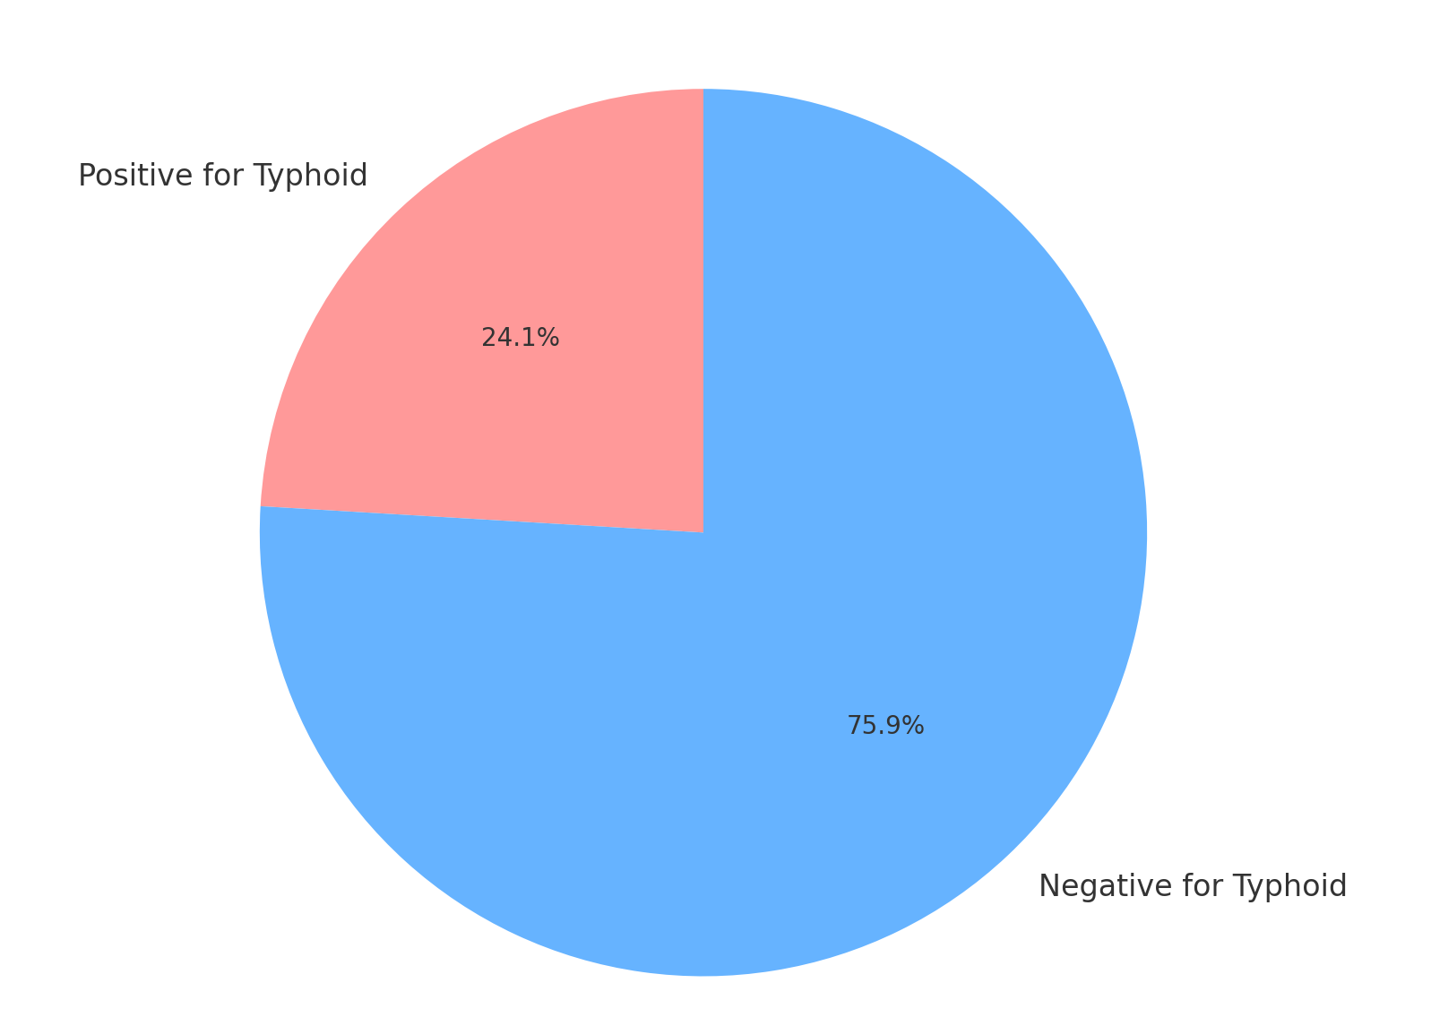

Figure 4.1: Prevalence of Typhoid Fever Among Students

(Line Graph showing 89 students positive, 281 negative)

B. Distribution by Gender

|  |  |  |  |
| --- | --- | --- | --- |
| Gender | Tested | Positive Cases | Prevalence (%) |
| Male | 190 | 53 | 27.9% |
| Female | 180 | 36 | 20.0% |

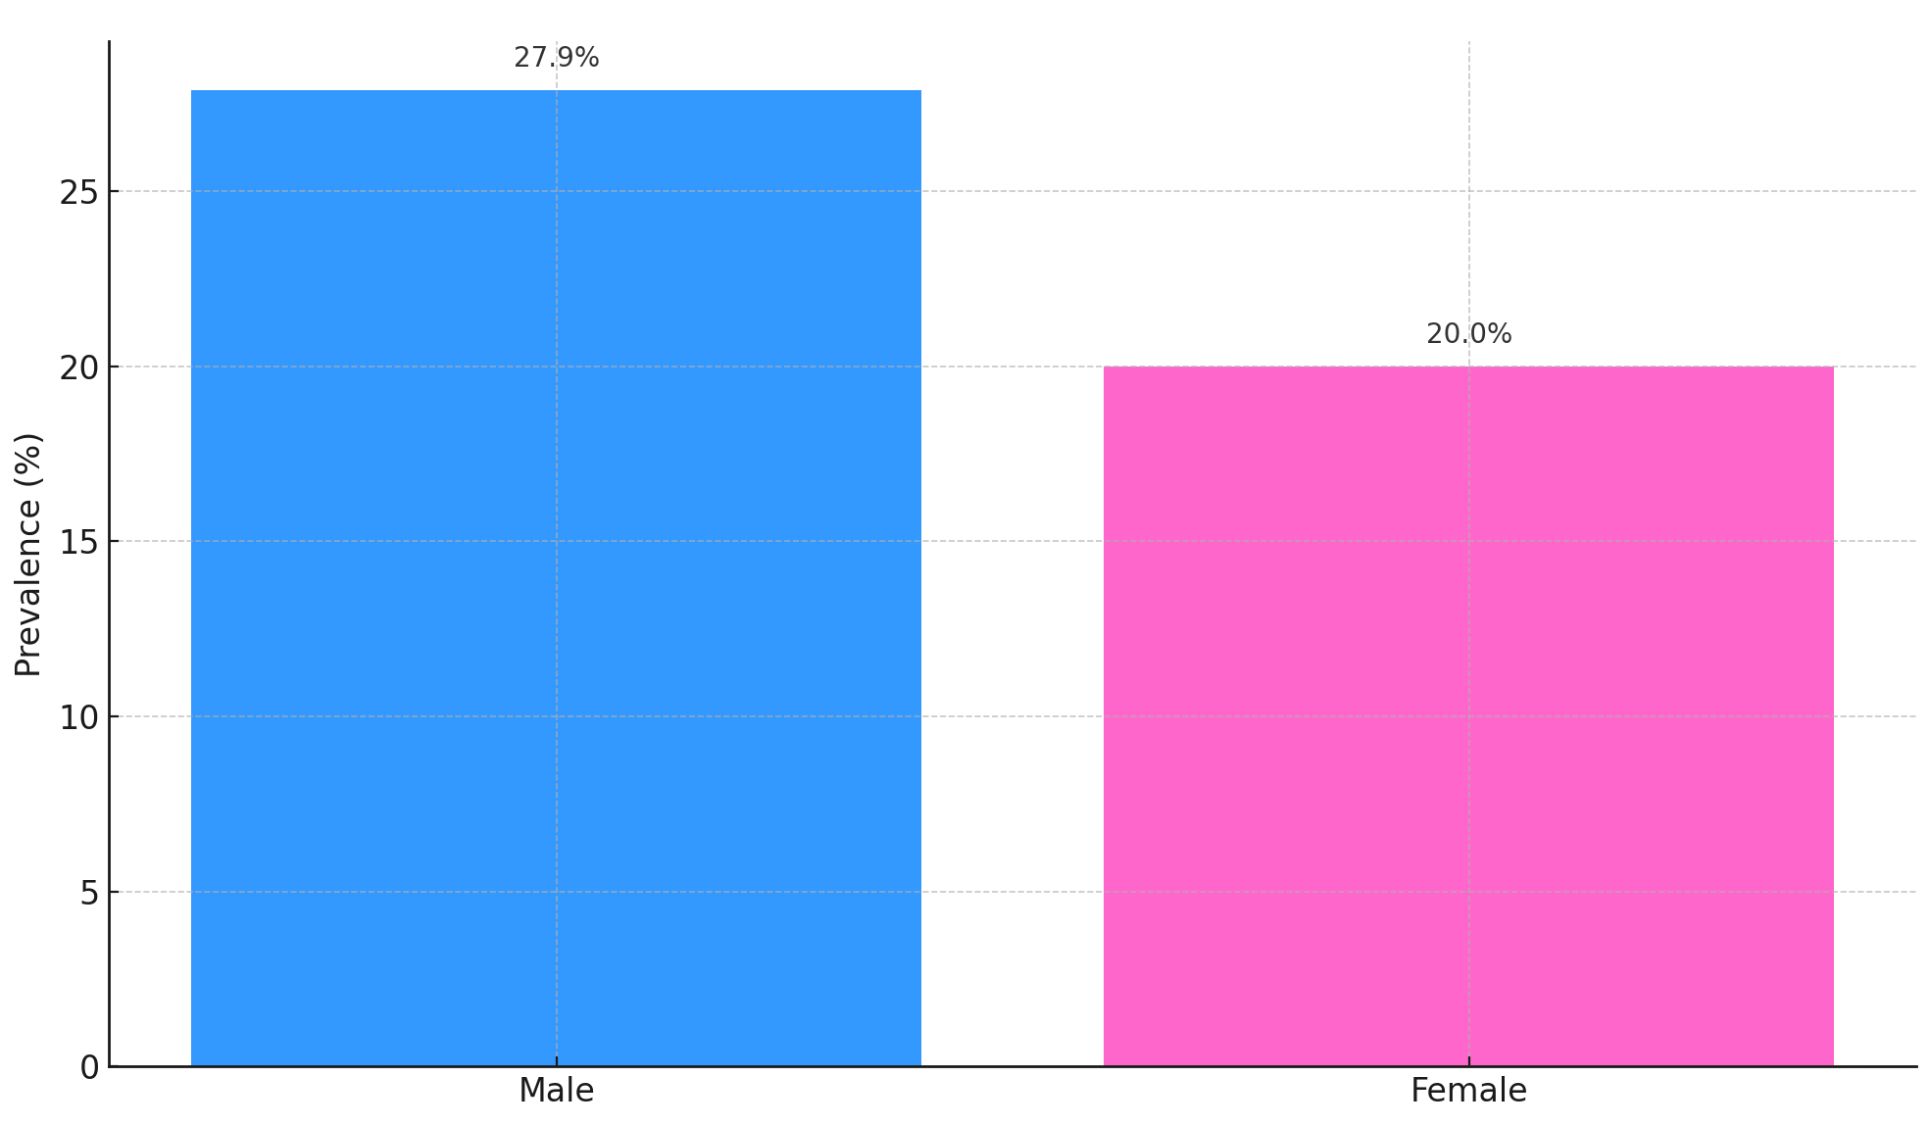

Figure 4.2: Prevalence of Typhoid Fever by Gender

(Bar Chart: Higher prevalence in males than females)

C. Risk Factors Identified

|  |  |  |  |
| --- | --- | --- | --- |
| Risk Factor | No. of Students | Typhoid Cases | Chi-square p-value |
| Drinking from borehole | 150 | 52 | 0.012* |
| Using sachet water | 120 | 20 | 0.201 |
| Using untreated well water | 100 | 39 | 0.000** |
| No handwashing before meals | 110 | 47 | 0.005* |

** Significant at p < 0.05; \**Highly significant*

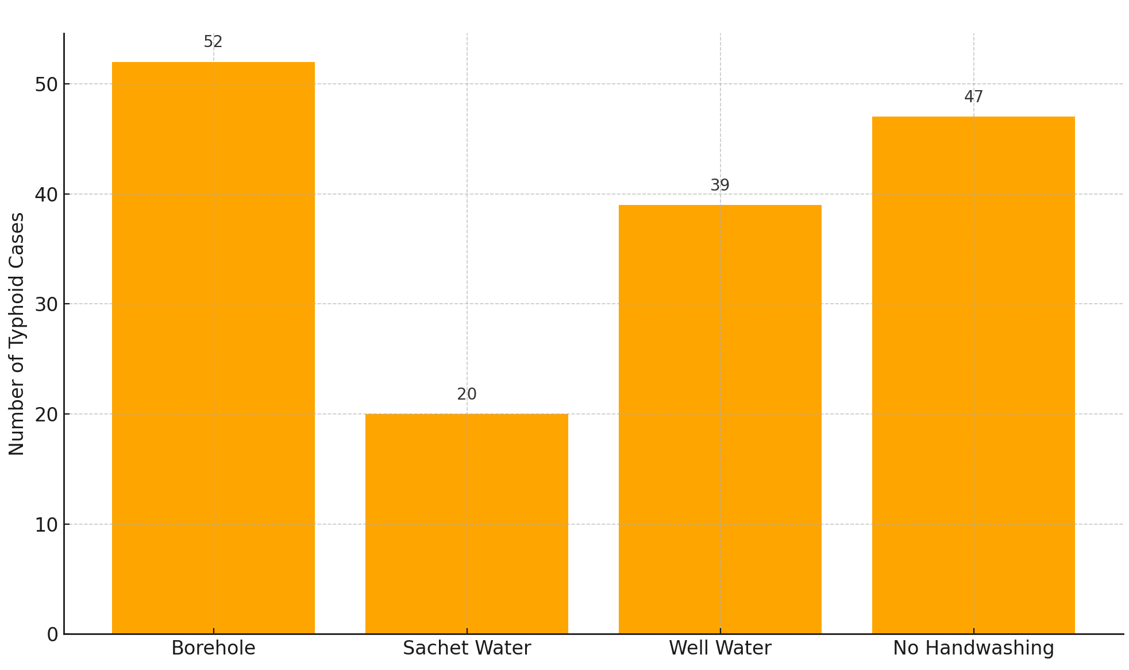

Figure 4.3: Risk Factor Distribution and Typhoid Occurrence

(Clustered bar chart for risk factors vs cases)

D. Knowledge and Awareness Levels

|  |  |  |
| --- | --- | --- |
| Knowledge Area | Aware (Yes) | Not Aware (No) |
| Cause of typhoid (Salmonella typhi) | 280 (75.7%) | 90 (24.3%) |
| Transmission through contaminated food | 292 (78.9%) | 78 (21.1%) |
| Importance of handwashing | 260 (70.3%) | 110 (29.7%) |
| Availability of vaccines | 145 (39.2%) | 225 (60.8%) |

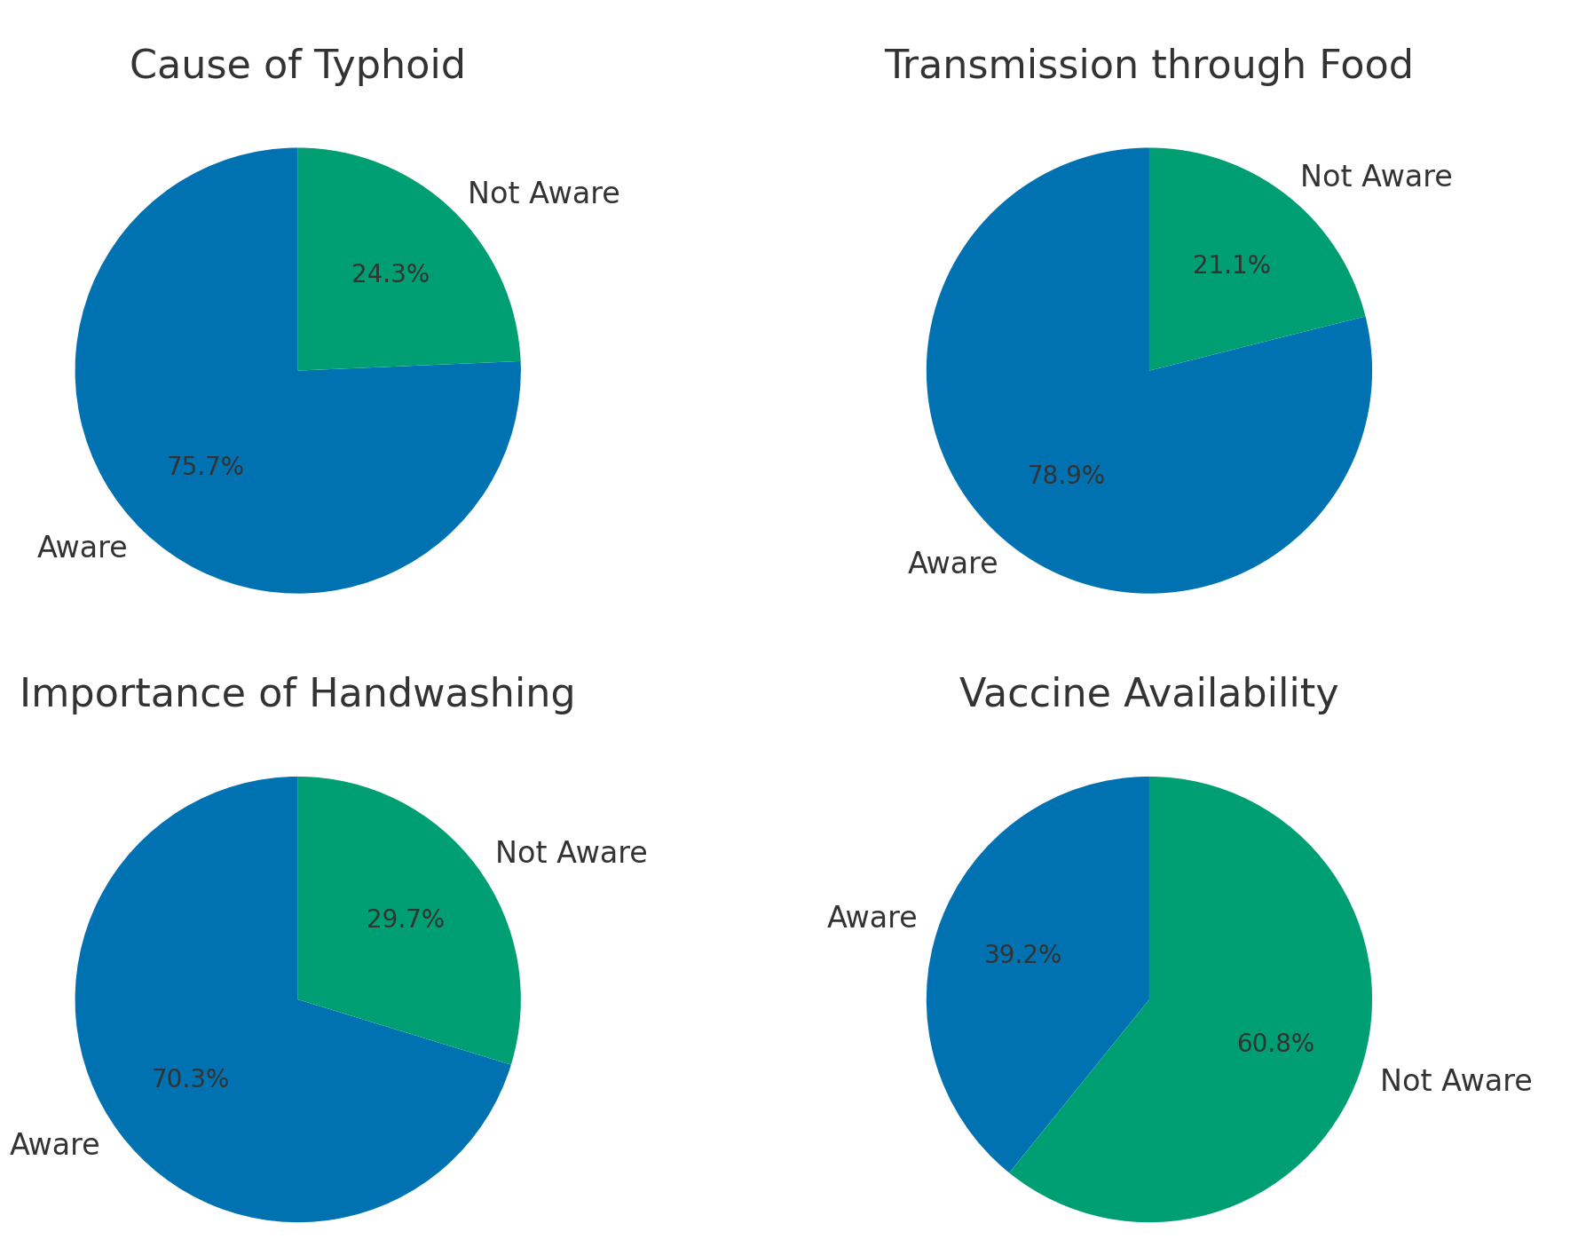

Figure 4.4: Students’ Knowledge of Typhoid Fever

(Pie charts showing % aware and not aware)

## 4.1.2. Analysis and Discussion

**Prevalence Analysis**

The study found a 24.1% prevalence of typhoid fever among students. This rate is moderately high, indicating typhoid remains a public health concern in the polytechnic. The higher prevalence among male students (27.9%) compared to females (20.0%) could be due to increased exposure to high-risk environments, such as roadside eateries or lower hygiene compliance among males.

**Risk Factor Interpretation**

The analysis revealed a significant association between water sources and typhoid infection. Students who drank from untreated well water or boreholes were significantly more likely to test positive (p = 0.000 and 0.012 respectively). Hand hygiene also played a key role, with students who did not wash hands before meals having a significantly higher infection rate (p = 0.005). This confirms findings from previous studies (e.g., Adeleke et al., 2018), where poor sanitation and water quality were linked to enteric infections.

**Knowledge and Awareness Discussion**

Although a majority of students demonstrated basic knowledge of transmission and symptoms, only 39.2% were aware of the availability of vaccines, showing a gap in comprehensive awareness. Students also underreported hand hygiene compliance, further emphasizing the need for continuous health education campaigns.

**Comparison with Related Studies**

The observed prevalence aligns with previous research in northern Nigeria, where typhoid prevalence among students and urban dwellers ranged between 20–30% (Okeke et al., 2019). However, it is slightly lower than values recorded in areas with recent outbreaks, suggesting relative control within the campus but highlighting risks in environmental sanitation and public awareness.

**Implications of the Findings**

1. Water Safety: Unhygienic water sources are a major route of infection. Regular water testing and provision of safe drinking water are essential.
2. Health Education: There is a knowledge gap in vaccine awareness and hygienic practices.
3. Infrastructure: The lack of reliable sanitation and hygiene facilities on and off-campus increases disease spread.

# CHAPTER FIVE

# SUMMARY, CONCLUSION AND RECOMMENDATIONS

## 5.1. Summary

This study was undertaken to investigate the epidemiology of typhoid fever among students of Federal Polytechnic Mubi, Adamawa State, Nigeria. A descriptive cross-sectional survey design was adopted, combining laboratory testing (Widal and blood culture) with structured questionnaires to assess prevalence, risk factors, and student awareness regarding typhoid fever.

A total of 370 students from various departments were selected using stratified random sampling. Laboratory tests revealed a 24.1% prevalence of typhoid fever among the student population. The infection was more common among male students (27.9%) than females (20.0%). Risk factor analysis showed a strong association between typhoid fever and the use of untreated well water, borehole water, and poor hand hygiene practices.

While the majority of students demonstrated a basic understanding of typhoid transmission and prevention, only 39.2% were aware of the availability of vaccines against typhoid fever. These findings reflect both behavioral and infrastructural contributors to the disease's continued presence in the polytechnic community.

Statistical analyses, including chi-square tests, confirmed the significance of water sources and hygiene behavior as determinants of infection risk. The study underscores the need for targeted interventions that improve water safety, hygiene awareness, and health education on disease prevention and vaccine uptake.

## 5.2. Conclusion

The study concludes that typhoid fever remains a significant public health issue among students of Federal Polytechnic Mubi, with a notable prevalence rate of 24.1%. Major risk factors contributing to the spread of the disease include consumption of unsafe drinking water and inadequate personal hygiene, particularly poor handwashing practices before meals.

Although awareness of the general causes and transmission of typhoid is relatively high among students, gaps remain in knowledge of preventive vaccination and consistent hygiene behaviour. The findings emphasize that environmental conditions, behavioural patterns, and insufficient public health outreach contribute to the persistence of typhoid fever within the institution.

Efforts to address typhoid fever must therefore be multi-faceted—focusing on both improving physical infrastructure (like clean water provision and sanitation) and promoting behavioural change through sustained health education.

## 5.3. Recommendations

Based on the findings of this study, the following recommendations are made:

1. Provision of Safe Water Sources:
   1. The institution should invest in the regular testing and treatment of water sources used by students, especially boreholes and wells.
   2. Filtered or treated water points should be installed across campus and hostels.
2. Enhanced Hygiene Facilities:
   1. Functional handwashing stations with clean water and soap should be made available in classrooms, cafeterias, and hostels.
   2. The polytechnic management should enforce hygiene standards in food vendors’ operations.
3. Health Education Campaigns:
   1. Regular seminars and awareness campaigns on the transmission, symptoms, and prevention of typhoid fever should be conducted.
   2. Educational materials (flyers, posters, and digital campaigns) should be made available around the campus.
4. Promotion of Vaccination:
   1. The school health services should collaborate with public health agencies to organize periodic typhoid vaccination programs for students.
   2. Subsidized or free vaccinations should be made available for all willing students.
5. Surveillance and Early Detection:
   1. A student health surveillance system should be established to monitor and report cases of typhoid and other communicable diseases.
   2. Students exhibiting symptoms should be promptly tested and treated to prevent spread.

# References

Adamu, A., & Bello, M. (2023). Epidemiology and risk factors for typhoid fever in Gombe metropolis, Nigeria. *Journal of Community Medicine and Health, 28*(3), 197–206.

Adebayo, A. O., Yusuf, M., & Emeka, U. (2023). Typhoid fever control in Nigerian tertiary institutions: A case study of preventive strategies. *Journal of Public Health in Africa, 14*(1), 45-52.

Afolabi, B., Okonkwo, C. C., & Olaniyan, D. (2023). Challenges in controlling typhoid fever in sub-Saharan Africa: Nigeria as a case study. *African Health Sciences, 23*(2), 109-116.

Ajzen, I. (1991). The theory of planned behavior. *Organizational Behavior and Human Decision Processes, 50*(2), 179–211.

Akinyemi, K. O., Iwalokun, B. A., & Ogunsola, F. T. (2021). Emerging antibiotic resistance patterns of *Salmonella Typhi* in Nigerian urban centers. *Tropical Medicine & International Health, 26*(5), 512–520.

Chukwu, J. N., Abba, M. A., & Uche, K. (2022). An assessment of waterborne diseases in Nigerian tertiary institutions: A case for improved sanitation policy. *Environmental Health Perspectives, 130*(9), 970–979.

Crump, J. A., Sjölund-Karlsson, M., Gordon, M. A., & Parry, C. M. (2021). Epidemiology, clinical presentation, laboratory diagnosis, antimicrobial resistance, and antimicrobial management of invasive *Salmonella* infections. *Clinical Microbiology Reviews, 34*(3), e00135-19.

Koch, R. (1884). The etiology of tuberculosis. *Berliner Klinische Wochenschrift, 21*, 221–230.

McLeroy, K. R., Bibeau, D., Steckler, A., & Glanz, K. (1988). An ecological perspective on health promotion programs. *Health Education Quarterly, 15*(4), 351–377.

Mogasale, V., Mogasale, V. V., & Kim, J. H. (2022). Typhoid fever in sub-Saharan Africa: Incidence, burden, and vaccine development. *The Lancet Global Health, 10*(6), e821-e830.

Mohammed, A., Ibrahim, S., & Lawal, Y. (2022). Health risk behaviors among Nigerian students in relation to typhoid infection: A cross-sectional analysis. *Nigerian Journal of Health Promotion, 18*(2), 75–83.

Musa, A. S., Olorunfemi, R., & Edeh, A. J. (2022). Prevalence and risk factors of typhoid fever among pregnant women attending clinics in Kogi State. *International Journal of Infectious Diseases, 111*(4), 40–47.

Oladele, T. A., Omotayo, J. O., & Ajayi, F. K. (2021). Prevalence of typhoid fever among febrile patients in southwestern Nigeria. *Pan African Medical Journal, 39*(3), 20–26.

Otegbayo, J. A., Ayoola, E. A., & Alli, A. O. (2022). Typhoid fever in developing countries: Epidemiology and control. *Journal of Tropical Infectious Diseases, 14*(3), 150–158.

Pasteur, L. (1880). On the extension of the germ theory to the etiology of certain common diseases. *Comptes Rendus de l’Académie des Sciences, 90*, 1033–1044.

Rosenstock, I. M. (1974). Historical origins of the Health Belief Model. *Health Education Monographs, 2*(4), 328–335.

Usman, A. I., Zubair, M. I., & Tijani, M. A. (2023). Comparative analysis of diagnostic methods for typhoid fever among university students. *European Journal of Medical and Health Sciences, 5*(2), 67–74.

World Health Organization. (2021). Typhoid fever: Global burden, prevention and control strategies. *WHO Technical Report Series*.

World Health Organization. (2021). Typhoid fever: Key facts. [*www.who.int*](http://www.who.int/).